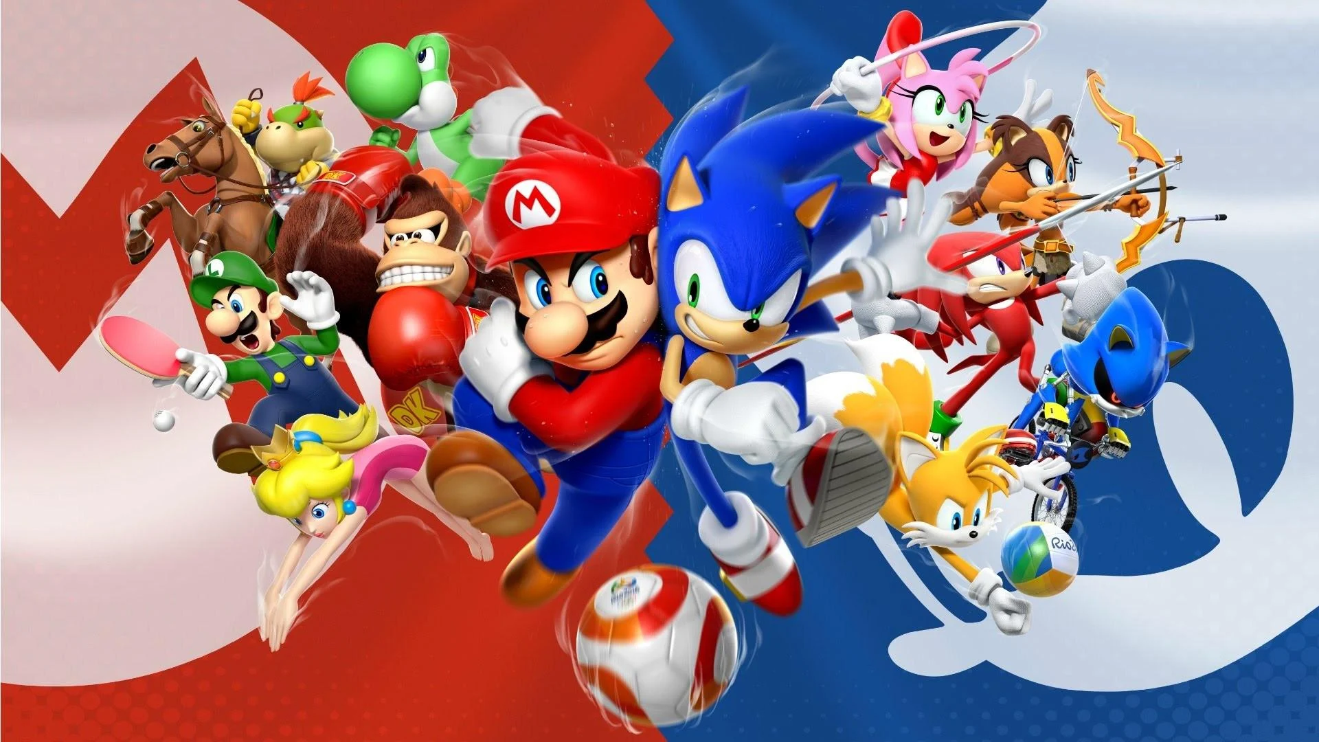

**Super Mario**



Core mechanics:

Run

Jump

Slide

Collect items/power ups

Dynamics:

Run + Jump to get to new locations

Jumping against a block breaks it, unlocking items

Jumping on enemies deal damage

Green pipe for transport

Use items to beat monsters / get to new locations / complete the level

Aesthetics:

Rescue the kidnapped princess from Bowser

Sense of accomplishment from completing tough level

**Sonic**

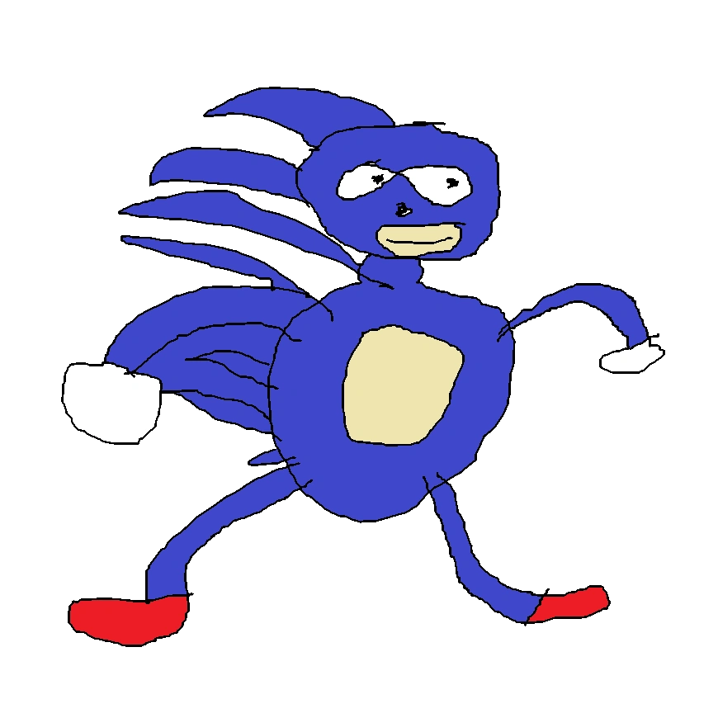

Core mechanics:

Run

Jump

Ball mode

Collect rings

Dynamics:

Escaping traps

Boss fights

Power Up

Speed pad for transport

Score System

Time counter

Lives counter

Aesthetics:

Satisfaction of collecting all the rings

I AM SPEED

Saving island from greedy corporate doctor egg

**Comparison**

Core mechanics:

Both mechanics are similar(run+jump+lower hitbox to dodge/dash)

Mario has items mechanics to help survive/defeat mobs

Sonic has ball mode to dash through enemies and break blocks

Dynamics:

Dynamics were a bit different

Both need to break blocks to advance through some levels.

Aesthetics:

Both aims to defeat a boss, that is terrorizing the island/kingdom, defeating said boss regains freedom, which is the accomplishment from doing a hard level